Build an SMA-based Signal Strategy
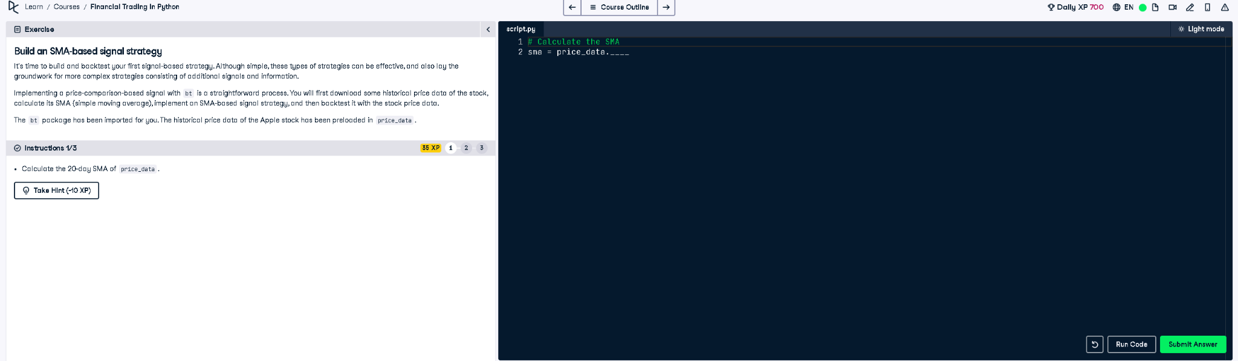

Full Python Answer
# Calculate the SMA (Simple Moving Average)
sma = price_data.rolling(window=20).mean()

Explanation in Simple Words
The task asks us to calculate the 20-day Simple Moving Average (SMA) of the stock prices in the variable `price_data`. This is done using a moving window of 20 days, which smooths out price trends. It helps identify signals in trading strategies like when to buy or sell.

